RAILWAY MANAGEMENT SYSTEM

Main Menu – Show available trains

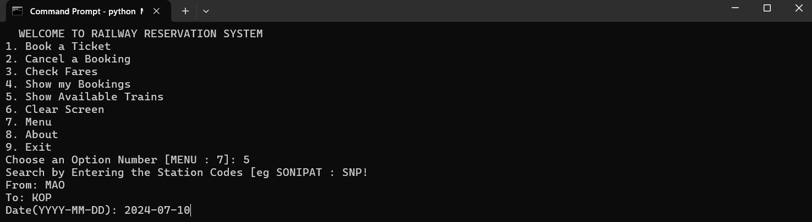

Book a Ticket

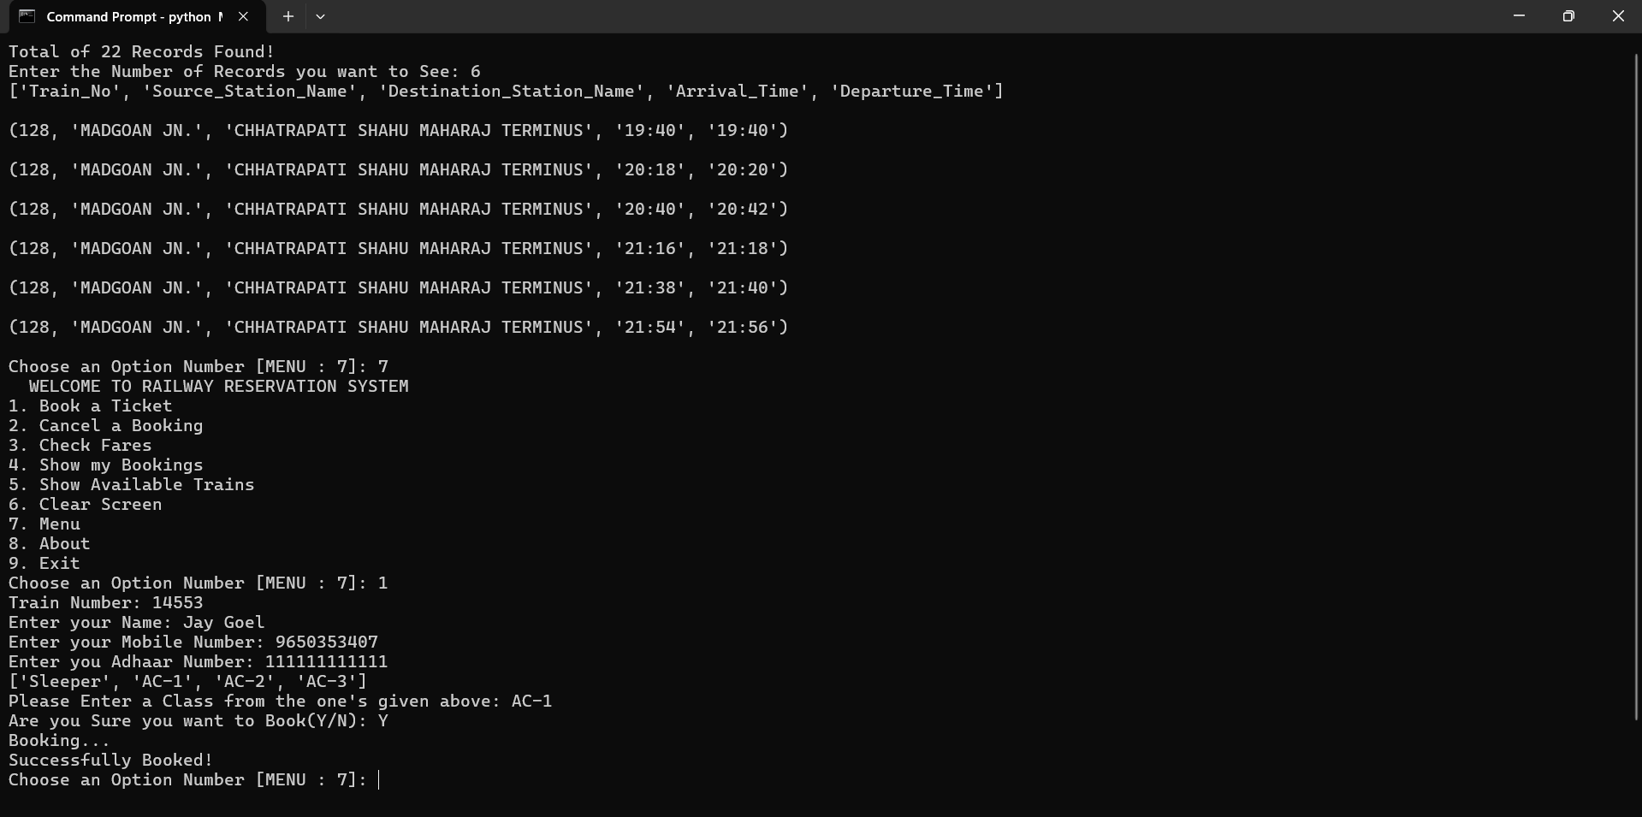

Check Fares of Train  
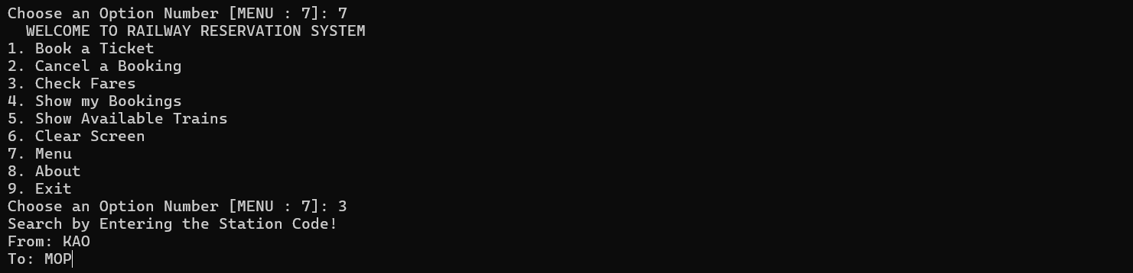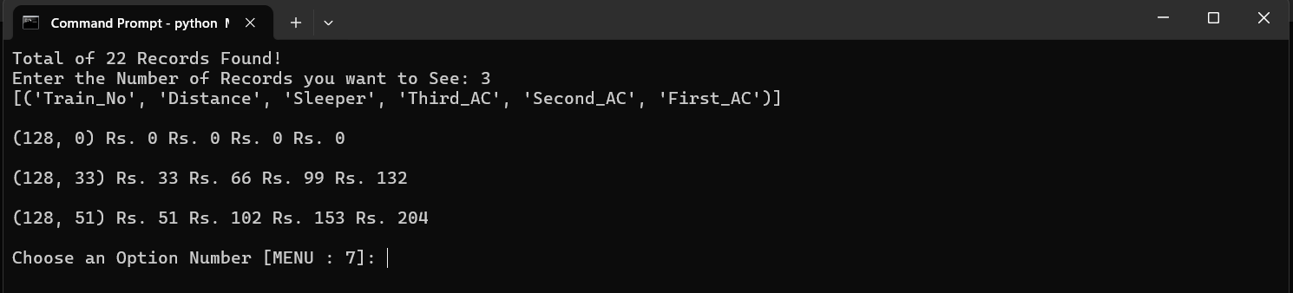

Show My Bookings  
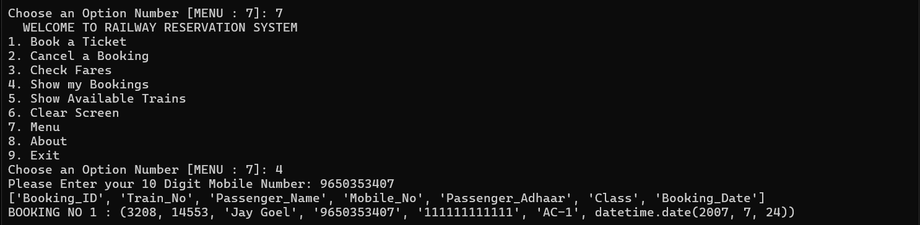

Cancel My Booking  
